Tarea 7

Instrucciones aritméticas

x= z +2 *8 -(a/b)-x

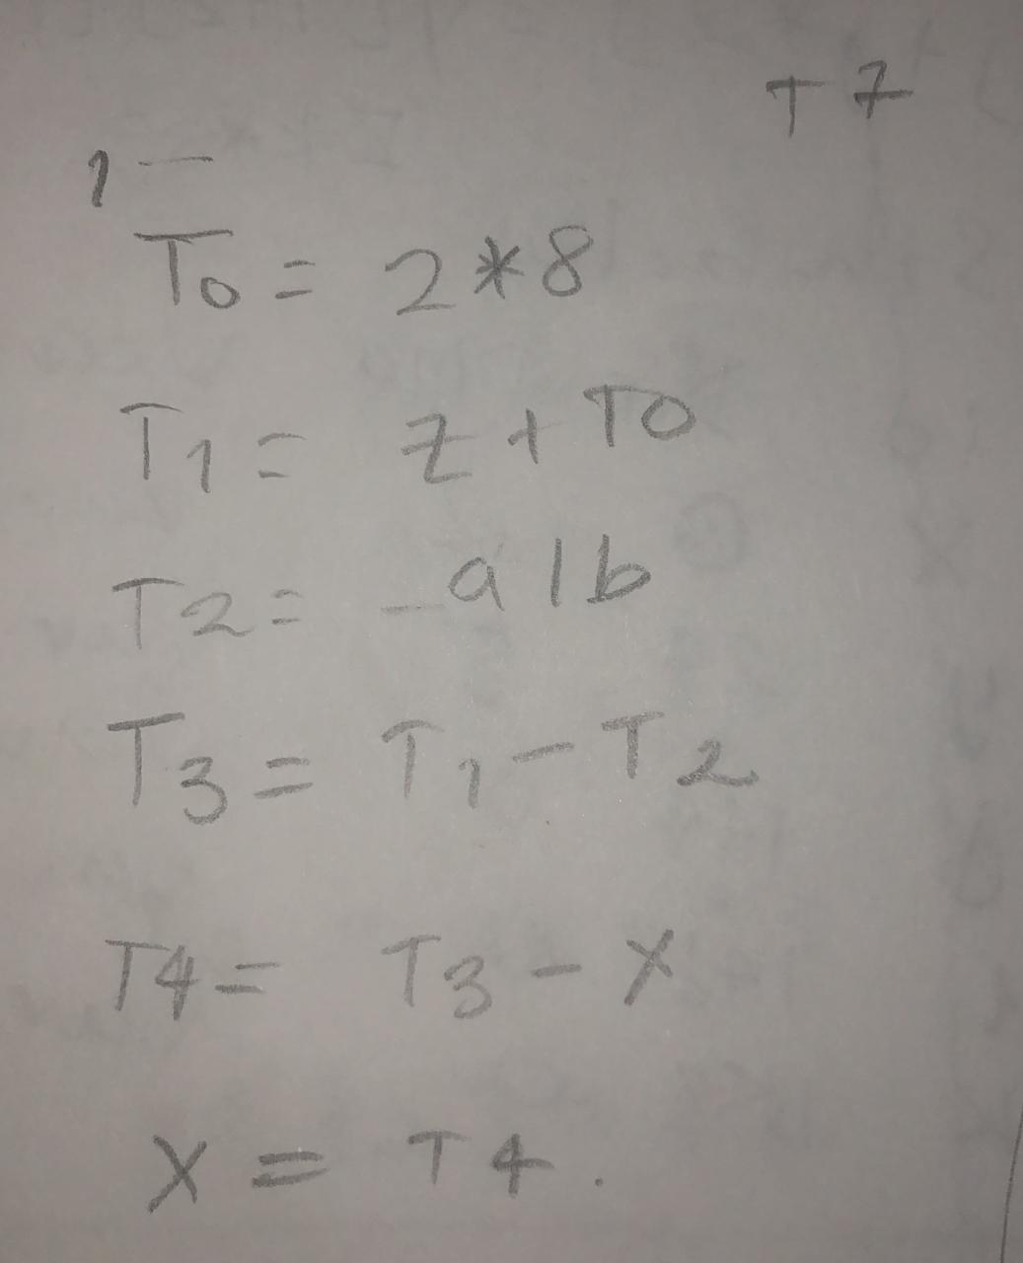

int x(6); ... x[j+j*2] = a * 3 /6;

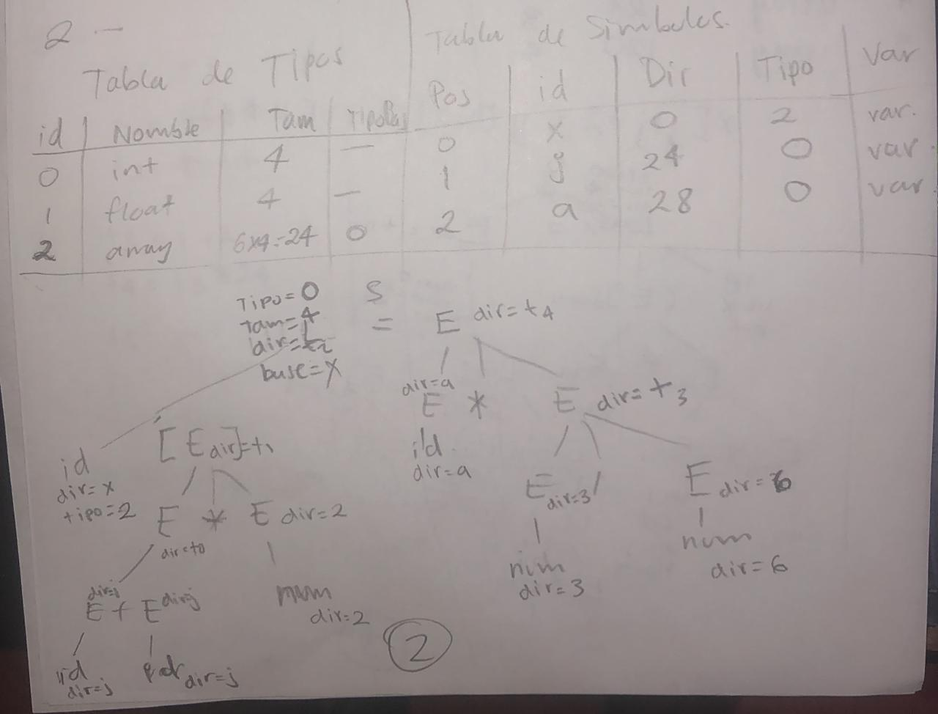  
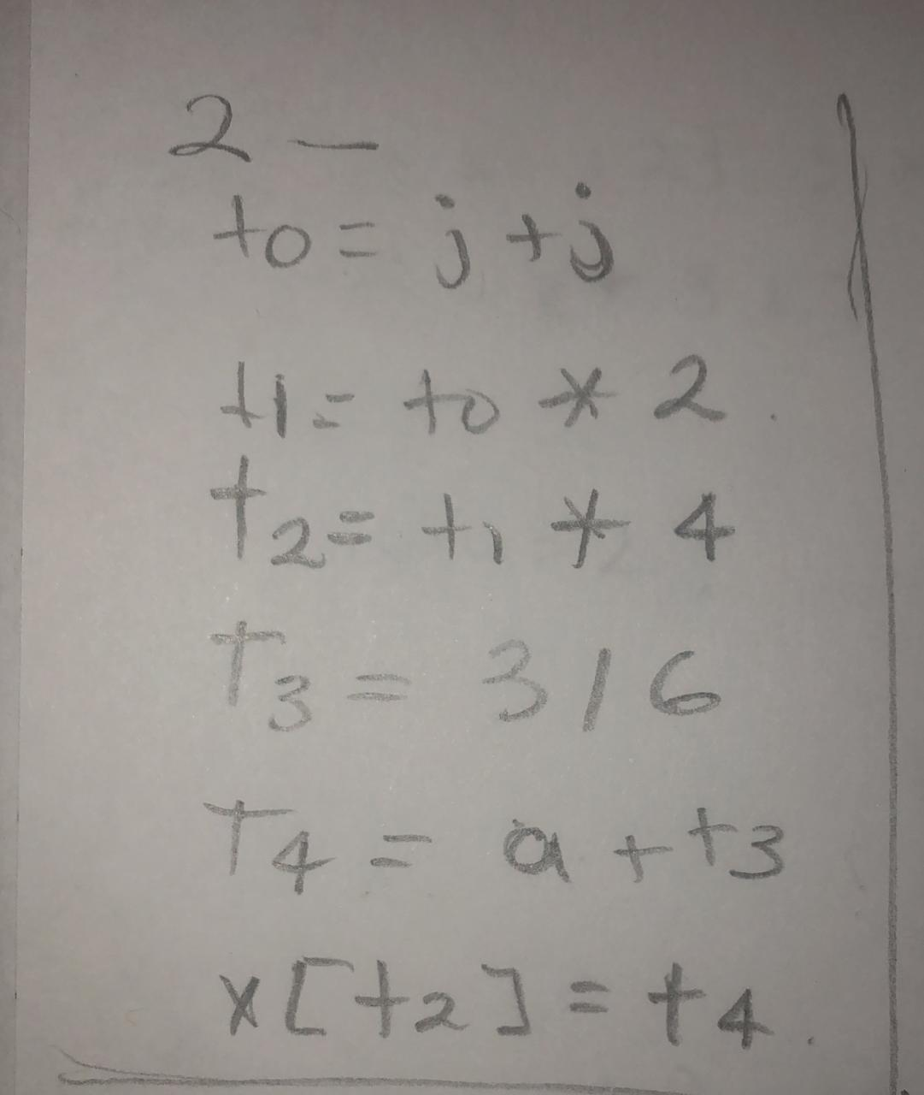

int x[6], y[5][3][2]; ... x[j+j*2] = y[i+2][[j-1][k*3];

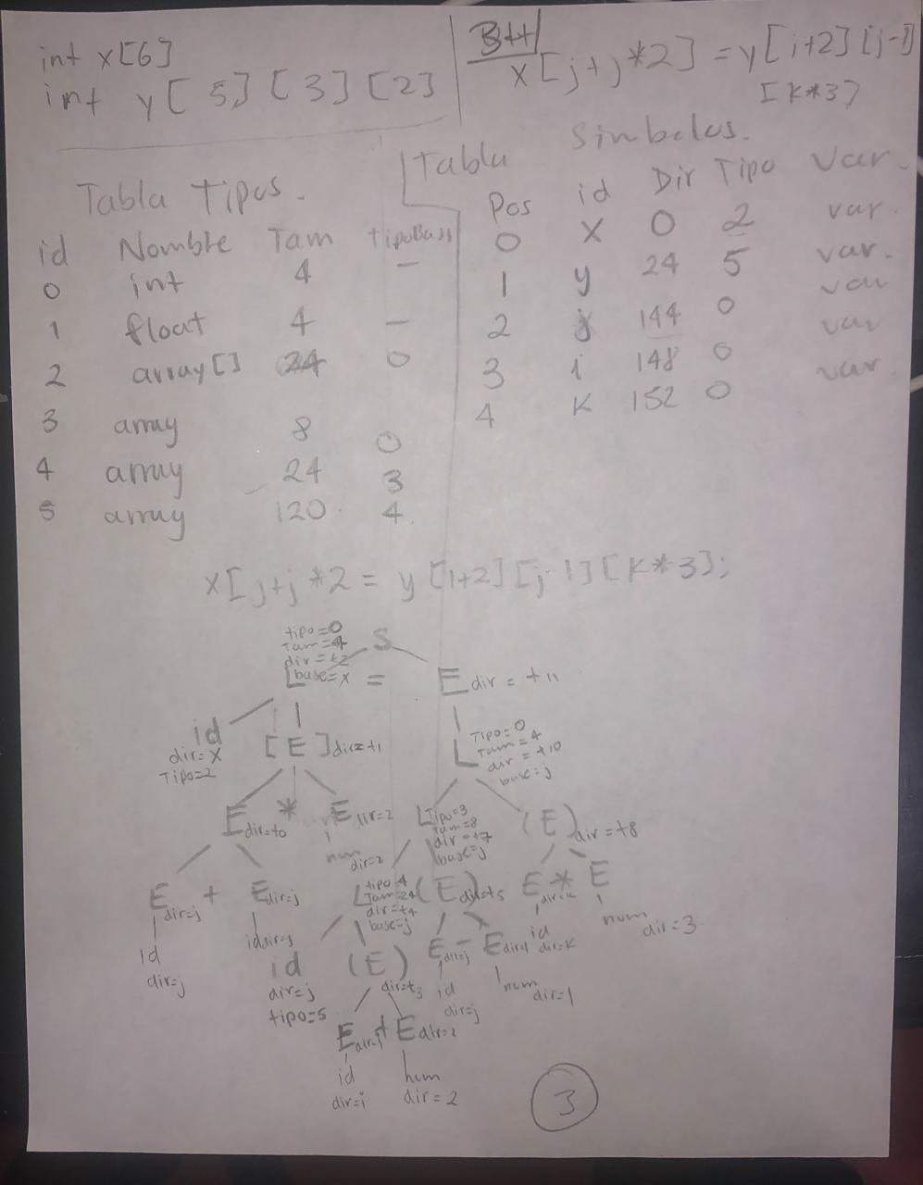

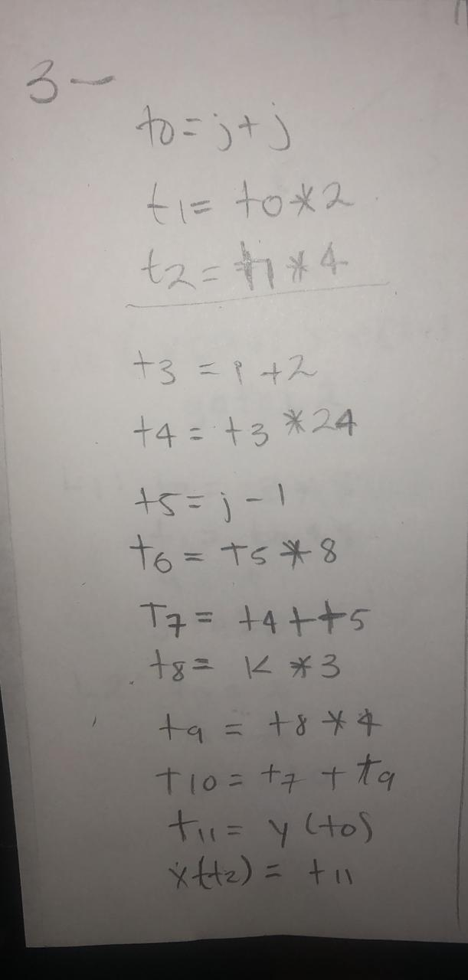

##### Instrucciones if, if-else, while, do-while

if( x[i+2] > x[i-1]) a = z*3+y; else a = 2;

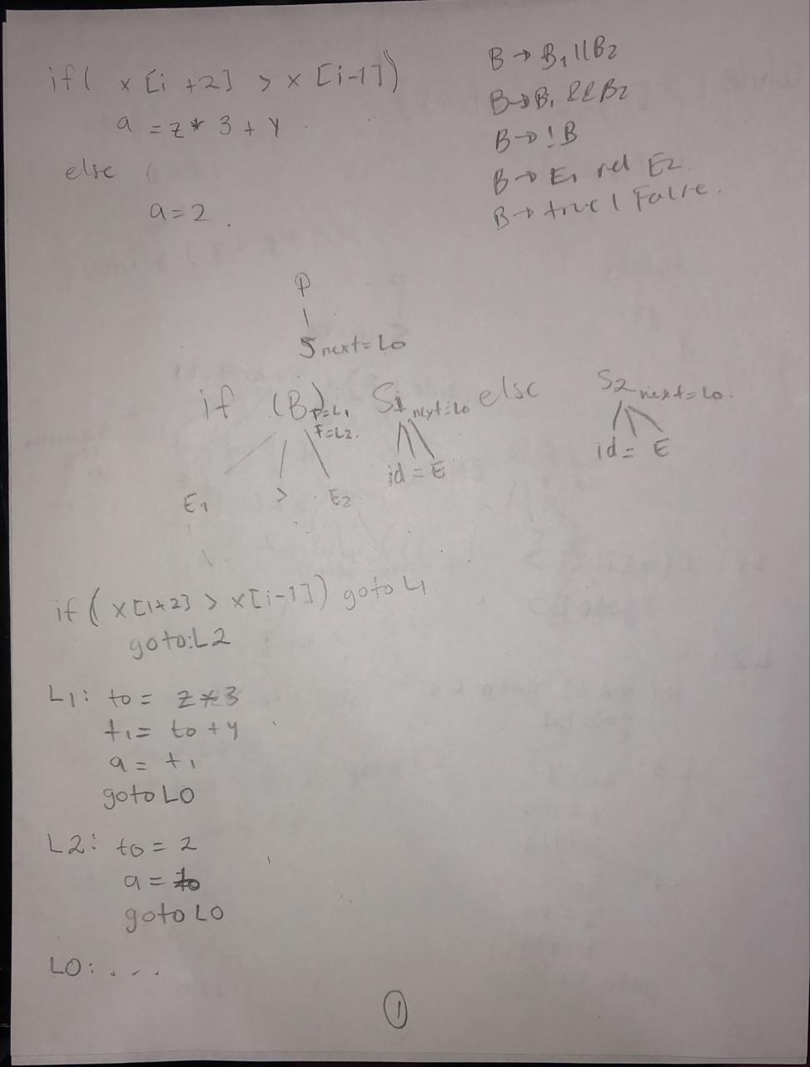

while( x[i+2] > x[i-1]) {if(y < 3) y =1; else y=0; }

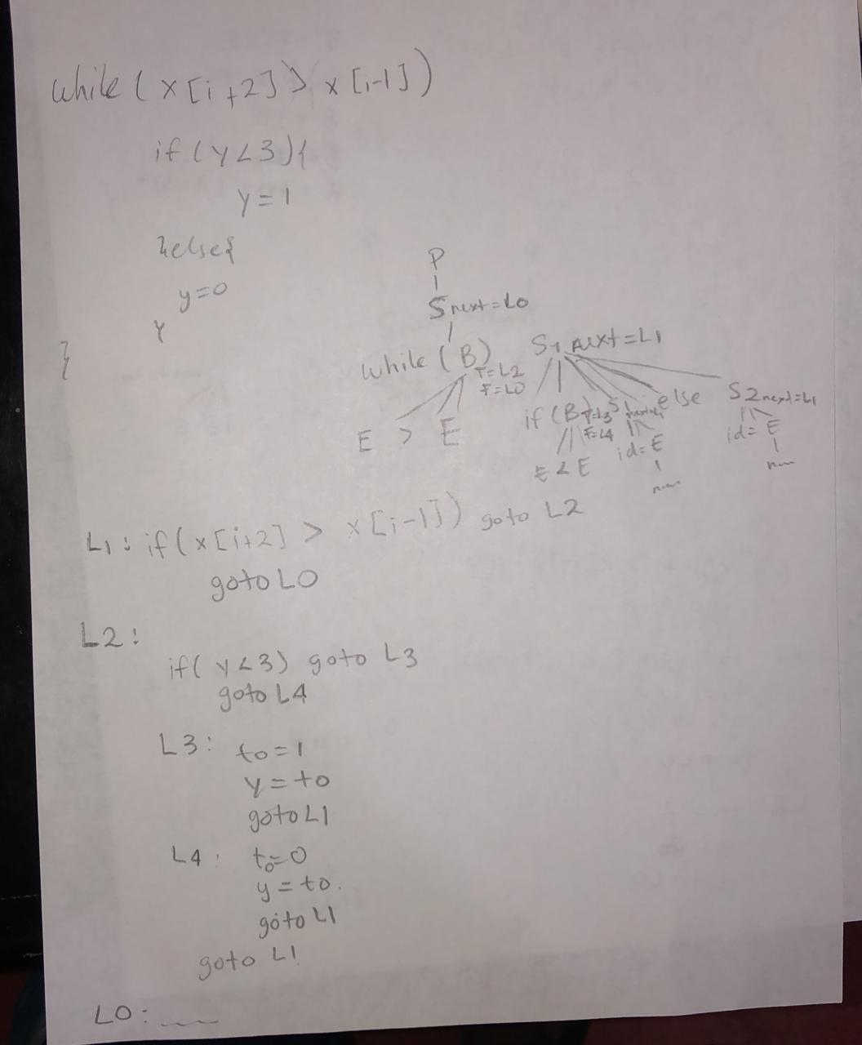

do i++; j++; while(x >z*5);

